**Chapter 1: MICROECONOMICS**

**Topic – 1: Introduction To Economics**

**Scarcity**

* **Scarce resources:** Resources which **aren’t** abundant & might be gotten in **exchange** of something.
* **Free resources:** Resources which are **abundant**, **might not be free** & can be gotten **without** any competition.
* **Rival goods:** Resources which when consumed by someone, **affects** how much others get of it.

**Factors Of Production**

* **Land or natural resources**
* **Labour**
* **Capital:** Something used in production.
* **Entrepreneurship:** Putting all the other factors together.

**Note!**

**🡪 Financial capital is a different thing.**

**🡪 Entrepreneurship is also known as technology.**

**Types Of Production**

* **Capital goods:** Producing goods which can be used in producing something else.
* **Consumption goods**

**Normative & Positive Statement**

* **Normative statement:** Statements which can be termed as **ethical statements** & are thus **subjective**.
* **Positive statement:** Statements which can be **tested** & might have results.

**Other Key Terms**

* **Occam’s razor:** Making **minimum assumptions** when performing analysis.
* **Ceteris paribus:** Means **"all else equal"**. It is the idea of considering changes which are clearly seen & **not** other factors.
* For example, how someone **reacts** to a **price** mustn’t be assuming anything about their **income**, **preference** etc.
* **Model:** **Simplification** of a system or a process.

**Note!**

**🡪 Normative information are indeed considered when studying economics.**

**Topic – 2: Economic Systems**

**Property Rights**

* **Household:** The **buyers** & **seller parties** of a firm.

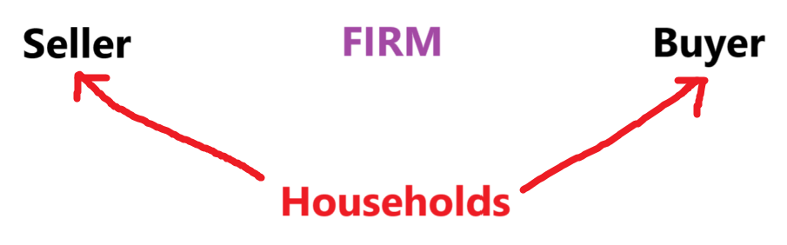

**Features Of Property**

* **Exclusive**
* **Enforceable:** Protected by law for its owner.
* **Transferable**

**Key Terms**

* **Resource/factor market:** Market where **sellers supply** land, labour, capital etc to firm.
* **Product market:** Market where **firms supply** the final product or services to buyers.
* **Wage:** What firms get paid for their **labour**.
* **Rent:** What firms get paid for their **land**.
* **Interest:** What firms get paid for their **capital**.
* **Profit:** What **entrepreneurs** get paid.
* **Market economy:** Economic resources are **privately owned** by individuals.
* **Command economy:** Economic decisions are taken by the government.

**Circular Flow Model**

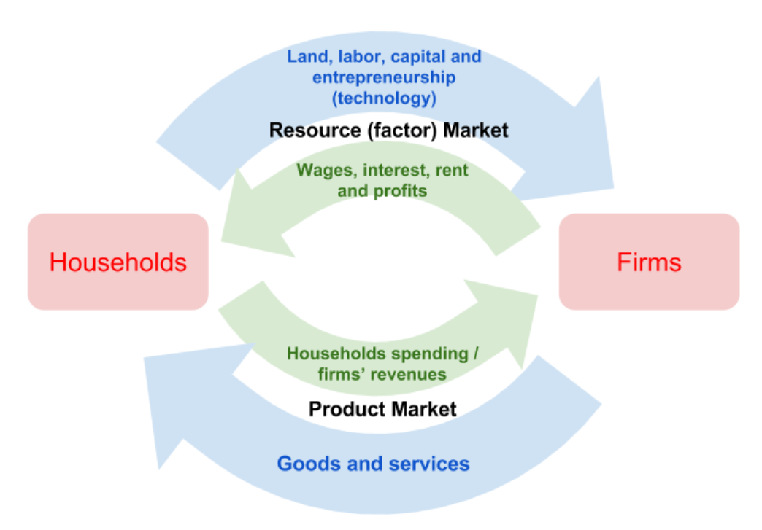

* Most economies lie between **market economy** & **command economy**.

**3 Basic Economic Questions**

* What should be produced?
* How should it be produced?
* Who will get the goods & services produced?